**SOLANO COMMUNITY COLLEGE**

**MT 162, ROBOTICS**

Fall, 2018

**LAB 1: INTRO LAB**

**Catharine Crayne**

9/18/18

**OBJECTIVE:**

1. To learn how to perform basic actions of the robot and learn the menu structure on the teach pendant.

**GROUP MEMBERS**

*N/A*

**MATERIALS:**

RoboGuide and Laptop, or Fanuc Robot

**PROCEDURE:**

1. Power up the robot controller. Place the robot in Teach Mode.
2. Turn on Teach Pendant and change the robot’s jog speed to 50%. Set the robot to jog in the JOINT coordinate system.
3. What is the fastest speed available to jog the robot?
4. What is the slowest speed?
5. What increments does the speed change by when the [+%] key is pressed?
6. What increments does the speed change by when the SHIFT key is pressed with the [+%] key?
7. Jog all 6 Axis’ of the robot.
8. Now set the robot to jog in the WORLD coordinate system.
9. Jog the robot in the WORLD frame so that you keep the point or tooltip perpendicular with each side of a box.
10. Press [MENU] key and take note to what the top of the pop up menu screen says.
11. Press [FCTN] key then select 0 for Next. Select Quick/Full Menu and press [ENTER].
12. Now press [MENU] key. What is changed on the menu?
13. Return the [MENU] to its full menu following step 11.
14. Jog the robot to align each axis witness mark using JOINT jogging. Change the speed to FINE or VFINE if needed.
15. Use the [POSN] key and record the values of each joint.
16. Using the MENU, go to SYSTEM, TYPE, and AXIS LIMITS.
17. Write down the axis limits for each joint.
18. Reduce the axis limit for axis 1 by 20 degrees in each direction. Restart the controller.
19. Jog joint 1 so that it generates a motion limit error. Enter into the MENU system and go to ALARM. View the Alarm History (HIST). Write down the error.
20. Press [SHIFT] and [DIAG] to display Cause and Remedy for that error.
21. Return the axis limit back to it original value. Restart the controller.
22. What is the Software Edition Number for your controller?
23. What is the Software Serial Number?
24. What is the F Number of the robot?

**RESULTS - DATA**

Step 3: 100%

Step 4: VFine

Step 5: 5%

Step 6: 50%

Step 10/12: Less options are available on the Quick Menu. The menu is called “Quick 1”.

Step 15:

Step 17:

Step 19: MOTN-017 Limit error (G:1, A2,3)

Step 22: V9.10P/08

Step 23: 144786

Step 24: F217912

**OBSERVATIONS**

Step 2 Step 3

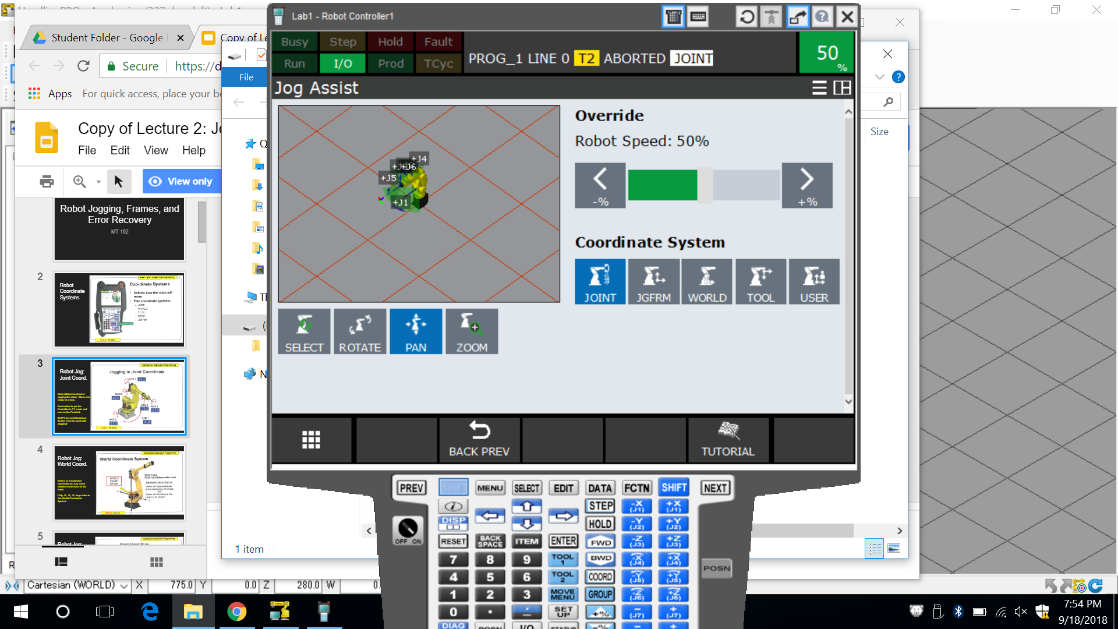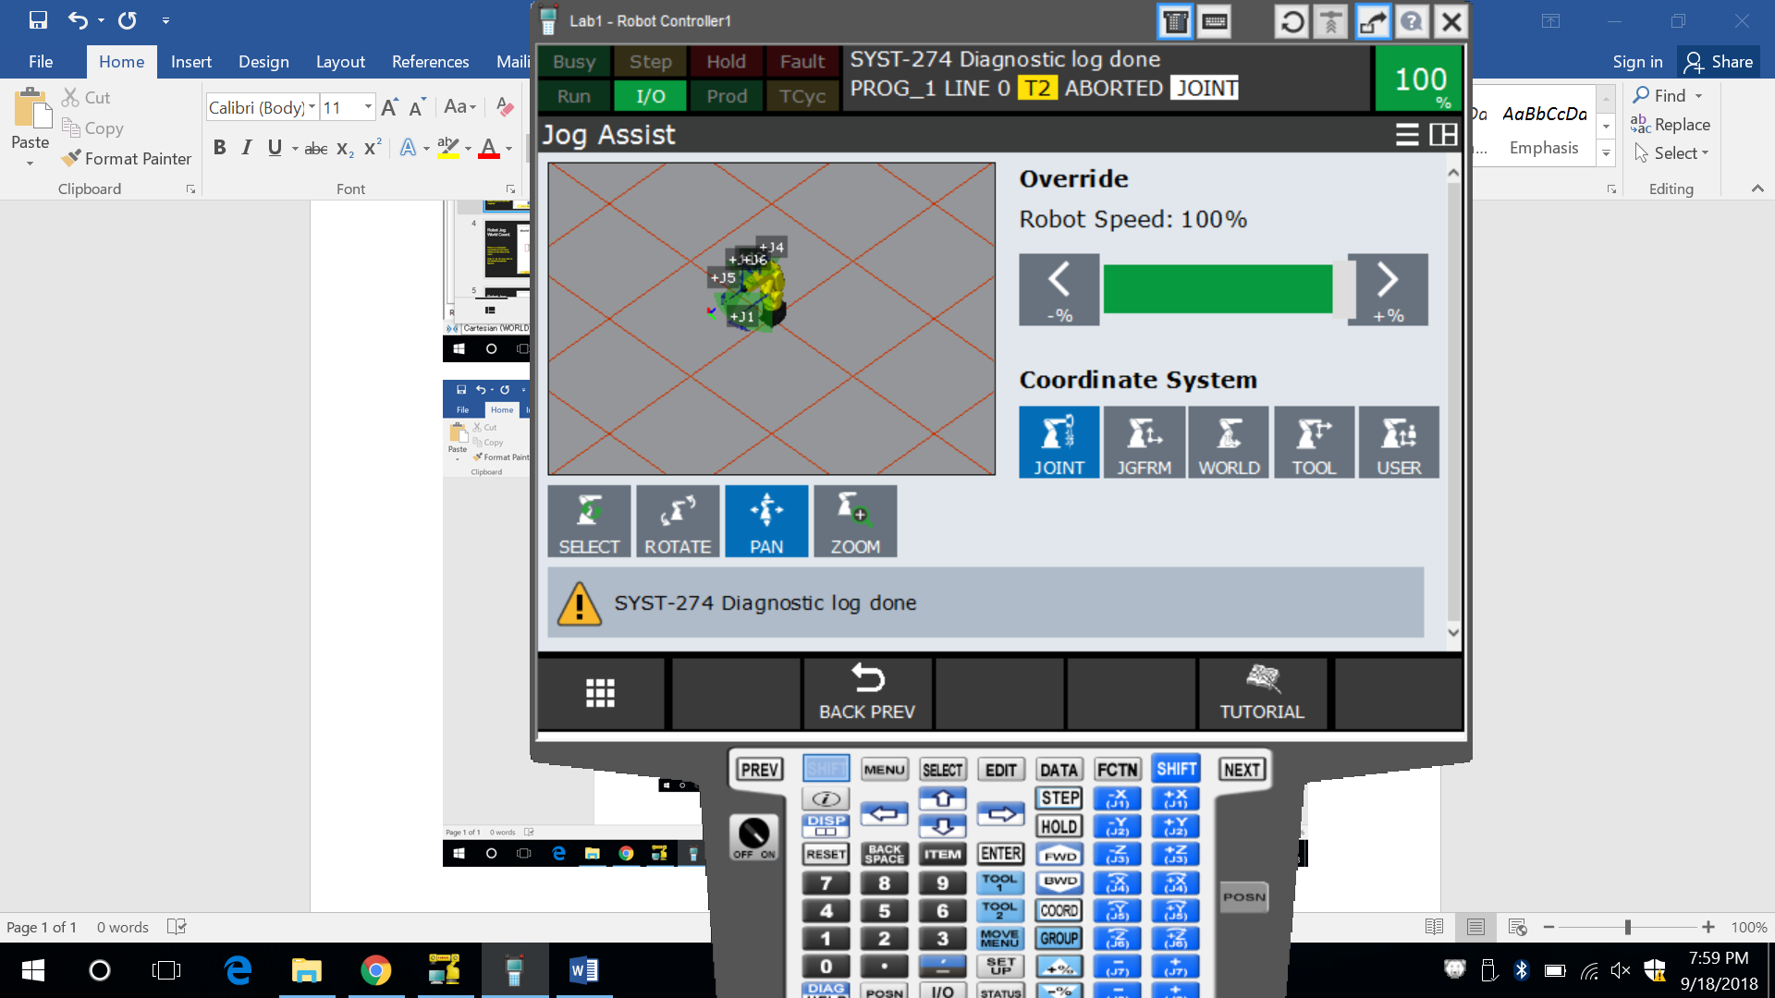

Step 4 Step 10

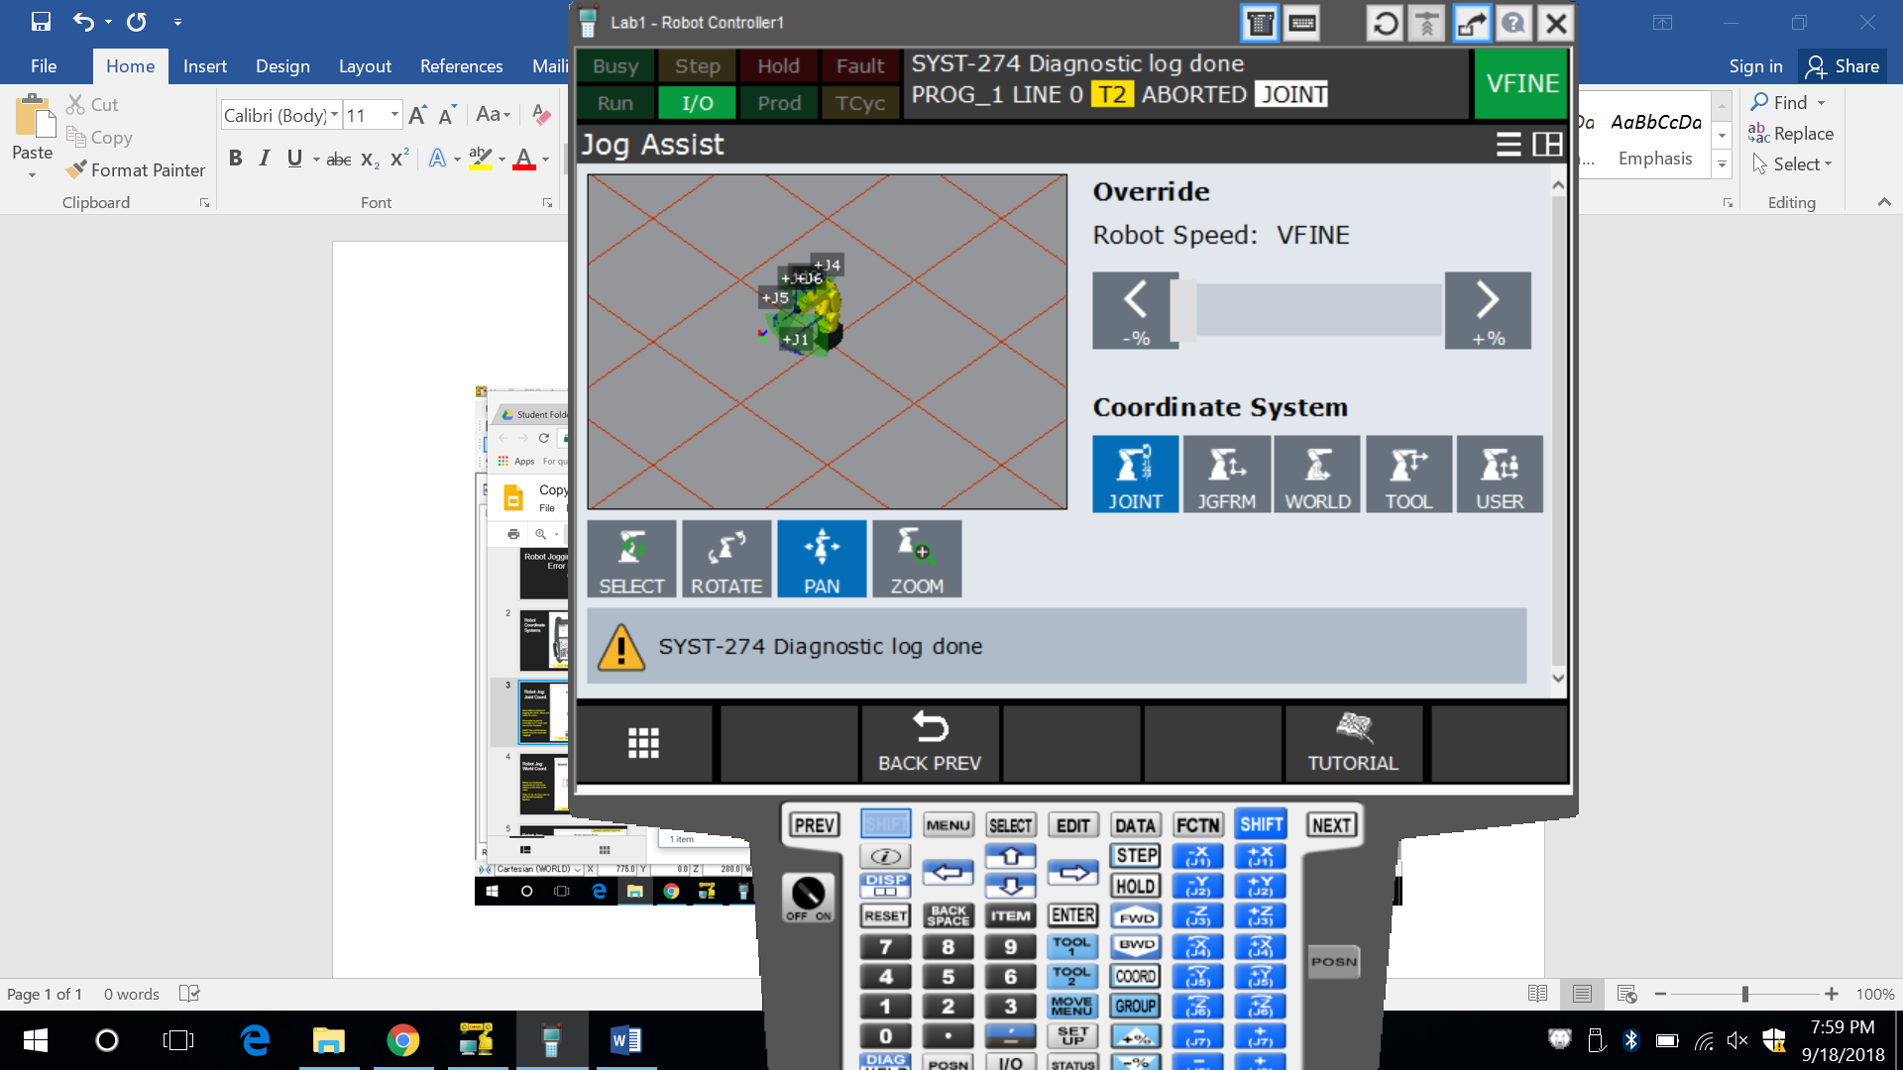 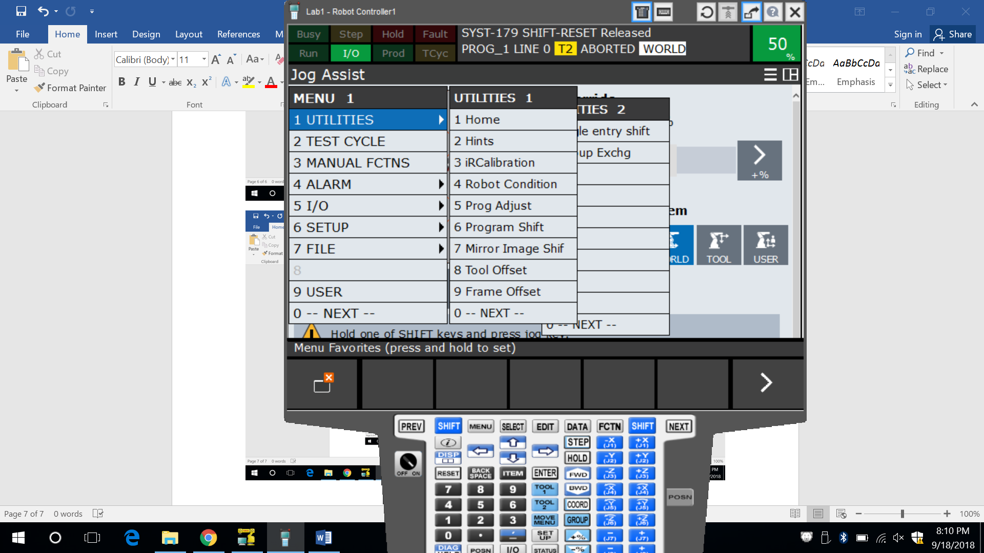

Step 11/12

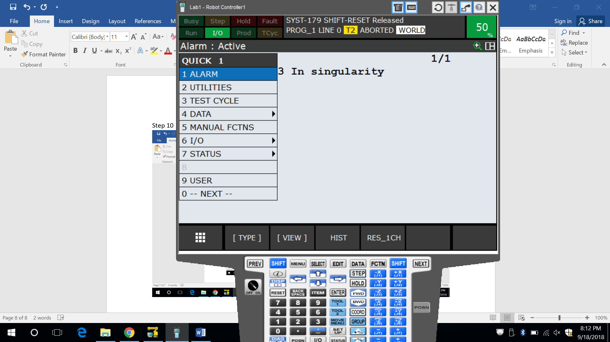

**PROBLEMS/QUESTIONS: ANSWER THESE!**

1. What key do you press to change coordinates when trying to jog the robot?

*Shift + (-X or +X or -Y or +Y or -Z or +Z)/J1-J6*

1. What direction does the robot move in the WORLD coordinate system for Z+ (floor mounted)

*Up (vertically)*

1. How can you access or find out the current coordinate values of the robots position?

*Positional data can be select by the MENU key or the POSN key.*

1. When a DCS or Motion Error occurs, what two keys must be pressed in order to clear the error?

*Shift + Reset*

1. Name two ways to control the robots motion limits or boundaries.

*Axis Limit software settings (raise (+) and lower (-) motion degree limitations) and Axis limit switches.*

1. How can a singularity error be corrected?

*Place the controller in Joint mode and jog 5-10 degrees out of the singularity.*